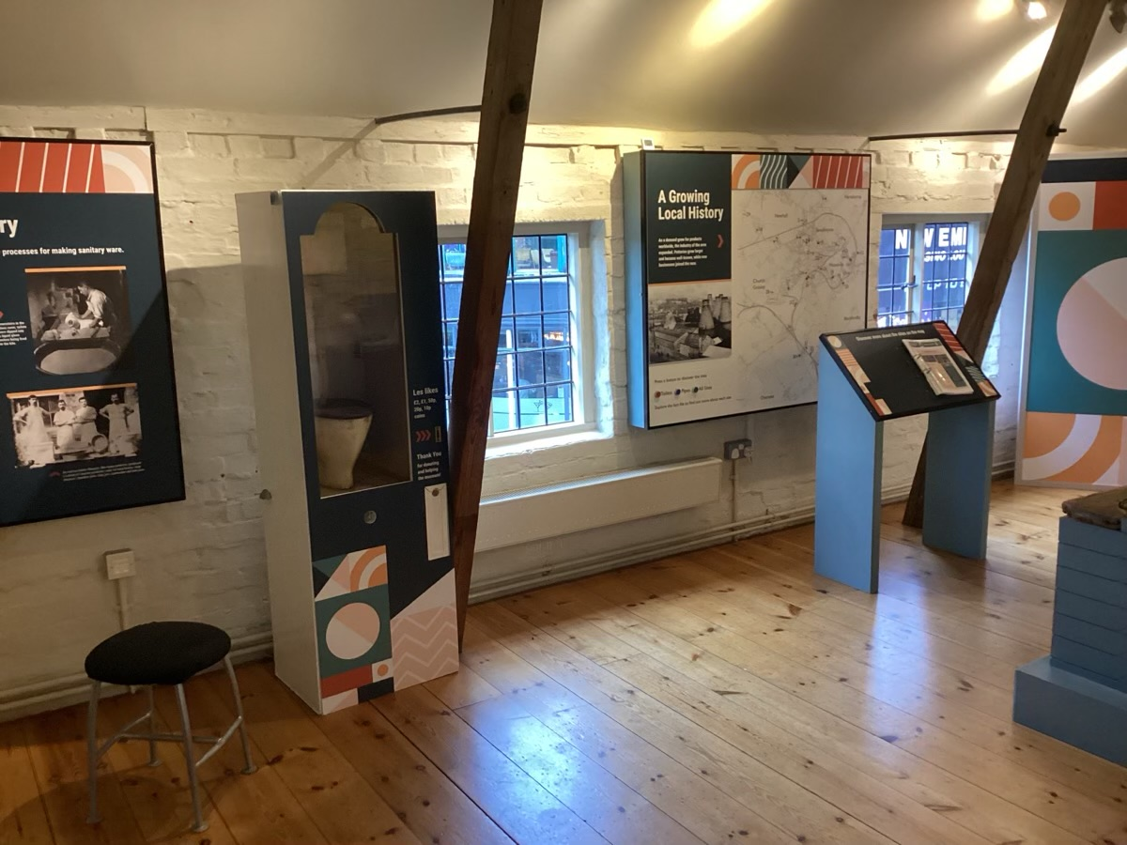

Accessibility Audit Toolkit - Museums

Welsh Museums Accreditation
Accreditation requirements in Wales include the provision of an Access Plan to be accessible to the public. Museums must be committed to improving physical, intellectual, and sensory access to their museum sites and collections, and the Access Plan will help with identifying priorities. This Accessibility Audit Toolkit supports the identification of areas where access can be improved and creates an Action Plan to prioritise improvements to museum access and facilities.
An Accessibility Audit should be reviewed every 3 years, or whenever there is a significant change in museum layout.
Museum name:
Accessibility Audit Date:
Review date:

Priority rating
Where there are potential health and safety risks or where failure to implement changes would be highly likely to attract legal implications. Immediate action is recommended to put the changes into effect.
Where action is recommended within the short term to alleviate an access problem or make improvements that will have a considerable impact.
Where action is recommended within 12 - 24 months to improve access.
Where the recommendation should be implemented as part of a long-term plan, alternatively, ‘Blue Sky’ thinking.


PLEASE NOTE: The Toolkit is not designed to replace a full access audit, nor is it an exhaustive or complete list of identifications or recommendations.

1: Travel to and approaching the site
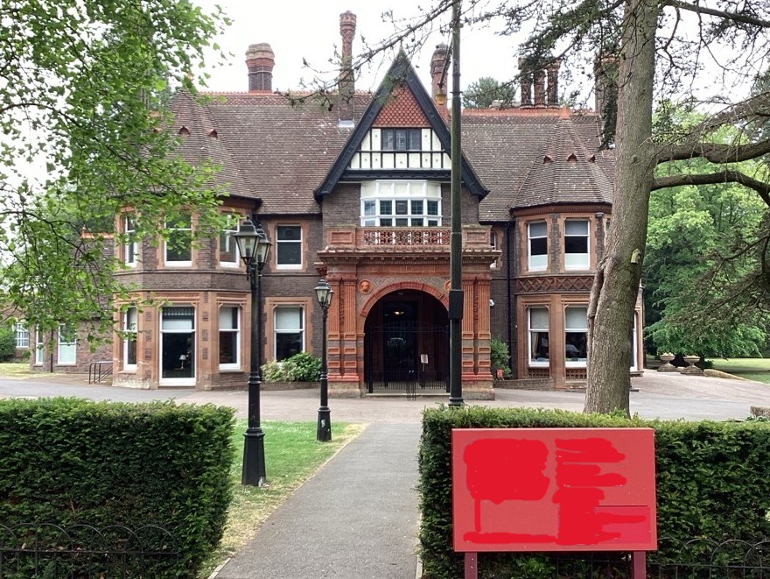
Sites should have easy access to public transport, be recognisable on approach and free from obstacles. Pre-visit information can assist visitors planning.
 |  | ü / û
1.1 | The museum entrance is within 400 metres of a bus stop or train station.
1.2 | The route from public transport and the highway is level and step-free with lowered kerbs. Tactile warnings are provided at crossing points.
1.3 | The route to the site is sufficiently wide with foliage trimmed back: minimum width 1200mm.
1.4 | Visual signage and landmarks are provided on approach routes to aid visitors in finding the museum.
1.5 | There are no hazardous features such as outward-opening doors, windows, or overhangs.
1.6 | Obstacles such as columns, bollards and posts feature contrasted markings for visibility.
1.7 | Information about getting to the museum is included on your website, including pre-visit information about facilities on site.

Actions: Travel to and approaching the site

2: Car parking and setting down points
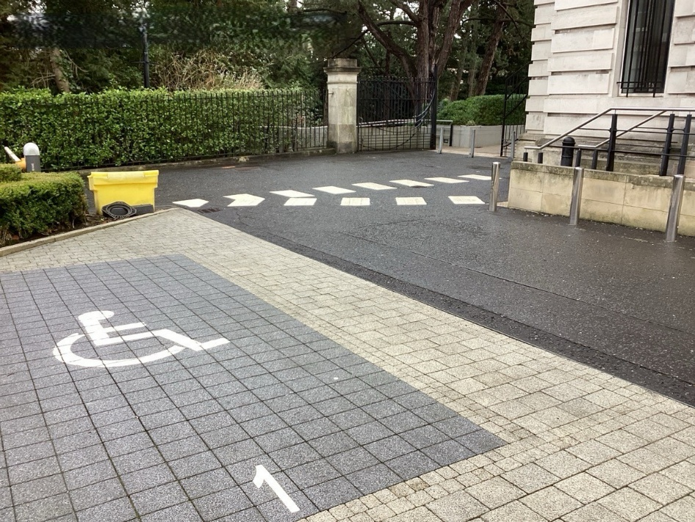
Parking or drop off close to an entrance allows ease of access. Accessible parking bays with sufficient space to use them, and step free access to the site, supports access for those with reduced mobility.
 |  | ü / û
2.1 | Visitors can be dropped off from a vehicle near the main entrance.
2.2 | Parking bays designated for disabled people are clearly signposted from the car park entrance.
2.3 | There are enough parking bays designated for disabled people: 6% of total capacity of the car park.
2.4 | Parking bays designated for disabled people are of a sufficient size: 4800mm long by 2400mm wide, with side and rear access areas 1200mm in width.
2.5 | Parking bays designated for disabled people are within 50 metres of the entrance they serve.
2.6 | Paths from parking bays designated for disabled people to the entrance have dropped kerbs with tactile warnings.
2.7 | The car park surface is smooth, even, and free from loose stones.

Actions: Car parking and setting down points

3: Pedestrian routes to the main entrance
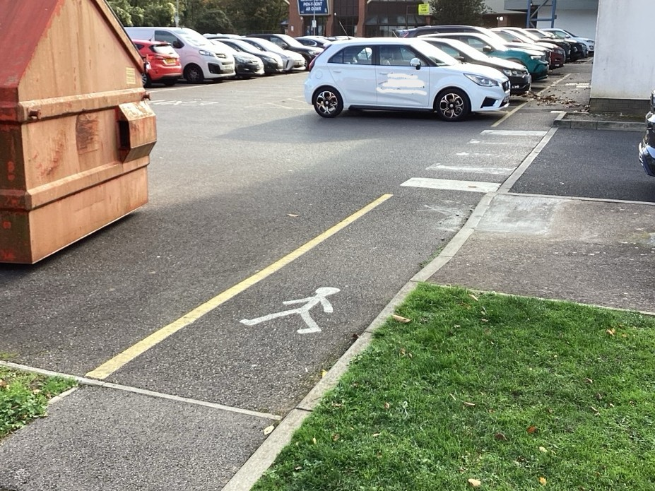
Routes from the highway to the entrance should be level, well maintained and provide safe access for all.
 |  | ü / û
3.1 | The main entrance is reached via a clear, level pathway: minimum width 1500mm, but 1800mm preferred.
3.2 | Path surfaces are firm, reasonably smooth and slip-resistant in all weathers.
3.3 | Directional signage is easy to see, clear and logical.
3.4 | Lighting produces an even level of illumination.
3.5 | Pedestrian and vehicular routes are separated and clearly differentiated.

Actions: Pedestrian routes to the main entrance

4: Entrance to the museum
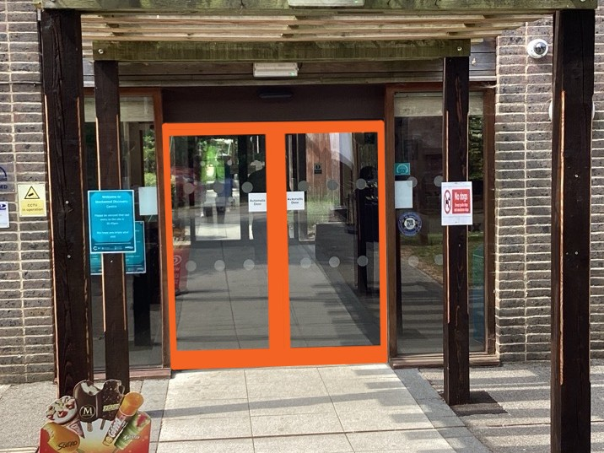
The entrance should be prominent and easy to use, with a step free route clearly identified.
 |  | ü / û
4.1 | A step free route is available into the museum, with an entrance door at least 900mm wide.
4.2 | The main entrance is clearly visible on approach. Where an alternative step free entrance is provided, it should be clearly signposted on approach.
4.3 | If access to an entrance is ramped, the ramp should not exceed 10m long and total rise of 500mm. Longer ramps must have a flat landing for rest.  The ramp should be at least 1500mm wide, have protective upstands on both sides, a continuous handrail on each side and a slip-resistant surface.
4.4 | If access to an entrance is stepped, step risers should be between 150mm - 170mm high, and treads between 300mm - 450mm long. The steps should have a continuous handrail and a slip resistant surface.
4.5 | The main entrance door and lobby doors are easy to open single-handedly or automatically. Clear indication of the opening direction is provided: push or pull.  Automated doors should stay open long enough to allow slow-moving persons to pass through. Door operation pads should be clearly visible on approach.
4.6 | People on each side of the entrance door, either standing or seated, can see each other and be seen.
4.7 | Fully glazed entrance doors have markings for safety and visibility provided at two heights, which are suitably colour contrasted viewed against the background.

Actions: Entrance to the museum

5: Reception
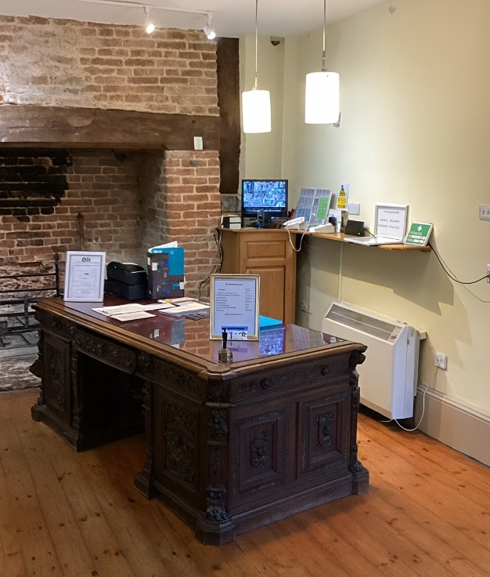
Reception desks and areas must be easy to locate and use by all.
 |  | ü / û
5.1 | The reception desk is visible from the entrance to the museum.
5.2 | The reception desk has a counter height for people both standing and seated: between 950mm - 1100mm for those standing, and 760mm high with a knee recess of 700mm deep for those seated.
5.3 | The reception desk is clear from obstructions and allows a minimum 1200mm width of circulation.
5.4 | An induction loop system and signage are provided to allow hearing aid users to access spoken information.
5.5 | If a glazed screen is required, it is non-reflective and free of glare, which could hinder lip-readers.
5.6 | Seating is provided in the reception area, some with armrests.

Actions: Reception

6: Horizontal circulation
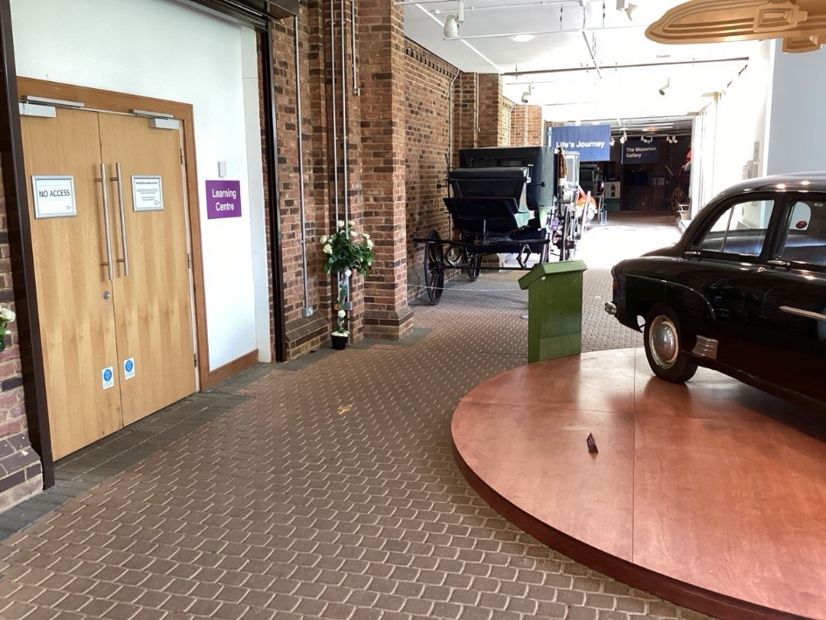
Ease of navigation and circulation makes areas accessible.
 |  | ü / û
6.1 | Clear signage is consistently positioned around the museum, using symbols as well as words and visual clues.
6.2 | Corridors are clear of obstructions and wide enough for a wheelchair user to manoeuvre: minimum 1200mm.
6.3 | Changes in floor levels are clearly indicated, with steps and ramps provided where floor level changes are greater than 300mm.
6.4 | Internal doors have a clear opening width sufficient for wheelchair users: minimum 750mm.
6.5 | Internal doors are light enough to open easily single-handed and have adequate space at the leading edge for a wheelchair user to open the door while keeping clear of the door swing space.
6.6 | Door handles and security devices are at a height suitable for both standing and seated users, and clearly distinguishable from the door and easily operated. Use of push button security locks is avoided.
6.7 | Colours, tones, and textures are contrasted to help people distinguish between surfaces, fixtures, and fittings.
6.8 | Outdoor paths should have:  a. No physical barriers that restrict access narrower than 1100mm.  b. Height clearance of at least 2400mm  c. Surfaces are firm and even in all weathers, clear of loose stones.  d. Resting points provided at least every 100m.
6.9 | Outdoor area gates are easy to operate, standing or seated, and have sufficient manoeuvring space either side.  Kissing gates and stiles are avoided.

Actions: Horizontal circulation

7: Vertical circulation
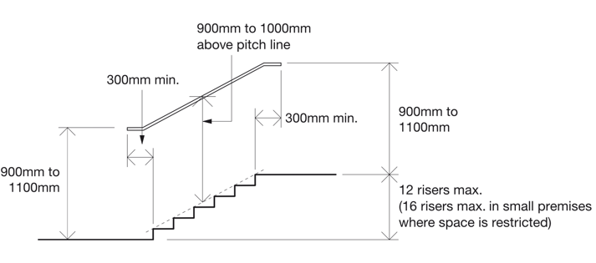
Source: Exhibitions for All
Visitors should be able to access all areas where building constraints allow.
 |  |  | ü / û
7.1 | All areas are accessible by level or ramped routes, or by a lift.
7.2 | Indoor and outdoor steps have:  a. a continuous handrail on both sides at heights that are convenient for all users,  b. colour contrasted nosing to the tread and riser,  c. a slip-resistant surface.  Single steps and open risers are avoided.
7.3 | Indoor and outdoor ramps with a gradient steeper than 1:20 (5%) have:  a. a continuous handrail on both sides at heights that are convenient for all users,  b. ramps longer than 10m or rise more than 500mm have a flat resting platform,  c. colour contrast between inclined and flat surfaces,  d. a slip-resistant surface.
7.4 | Lift car dimensions are sufficient to allow space for wheelchair users: 1400mm x 1100mm minimum.  Lift doors open wide enough for wheelchair users: 800mm minimum.  Lift car controls are located between 900mm and 1200mm from the car floor and have contrast and tactile features to identify each control.
7.5 | Wheelchair platform lifts and stairlifts have:  a. minimum platform dimensions of 800mm x 1250mm,  b. continuous pressure controls,  c. clear instructions for use,  d. controls designed to prevent unauthorised use,  e. minimum load capacity of 250kg.

Actions: Vertical circulation

8: WC’s – Accessible and General
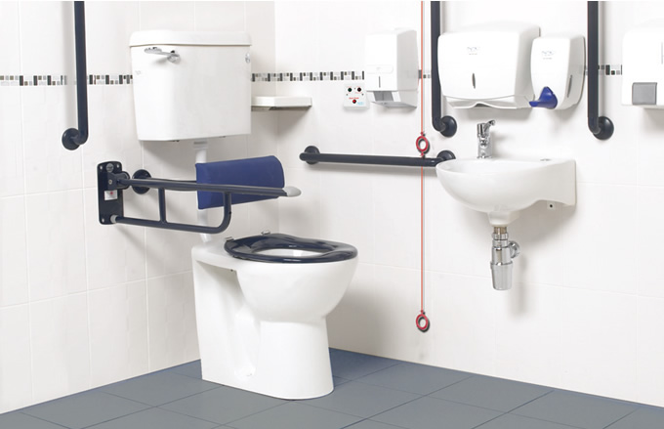
Source: www.unek.co.uk
At least one accessible WC should be provided, which has all the required fittings correctly positioned to allow use of the facility.
 |  |  | ü / û
8.1 | Where there is space for only one WC in a building, it is a wheelchair accessible unisex type: minimum dimensions 2200mm x 1500mm.  The WC is located as close as possible to the entrance, within 40m of other WCs and has sufficient space available outside the toilet compartment for a wheelchair user to manoeuvre.  Wheelchair accessible unisex toilets should not be used for baby changing, unless the cubicle is larger at 2200mm x 2000mm.
8.2 | Accessible WCs have door controls, locks, and light switches which are easily reached and operated.  Doors are fitted with a horizontal closing bar fixed to the inside face and are capable of being opened outwards, from the outside, in case of emergency.
8.3 | Accessible WCs are fitted with colour contrasted:  a. vertical grab rail to the wall behind the WC,  b. horizontal grab rail to the wall aside the WC,  c. drop down grab rail between the WC and transfer area,  d. grab rails each side of the sink.  e. colour contrast between wall and floor finishes is provided.
8.4 | Accessible WCs have a flushing mechanism positioned on the open or transfer side of the WC, capable of being operated using a closed fist.
8.5 | Accessible WCs have hand washing and dry facilities within easy reach of someone seated on the WC.
8.6 | Accessible WCs include:  a. taps which are controlled automatically, or capable of being operated using a closed fist,  b. wall-mounted soap dispenser and paper towel dispenser above the sink at 800mm-1000mm above floor  c. toilet paper dispenser aside the WC set at 800mm-1000mm above floor,  d. disposal bin between sink and door,  e. shelf between sink and door set at 720mm-740mm above floor,  f. full-length mirror to the far wall,  g. clothes hooks.
8.7 | Accessible WCs have a WC pan that can accept a variable height toilet seat riser.  A low-level cistern or back rest is provided to support the user.
8.8 | Accessible WCs have an emergency assistance alarm pull cord, hanging free within easy reach from the floor, with visual and audible indicators (distinguishable from the fire alarm) and a reset button reachable from a wheelchair and the WC.
8.9 | The transfer side of the toilet pan is kept clear of any obstacles that may deny wheelchair users all the transferring techniques.
8.10 | Where there is no accessible WC available, there is provision of at least one enlarged cubicle in a separate-sex toilet to aid ambulant disabled people or those who need an enlarged space.
8.11 | All WCs have:  a. doors light enough to open easily,  b. slip-resistant flooring,  c. fittings and sanitaryware contrasted so they are easily distinguishable from their surroundings,  d. door controls which are easily gripped and operated,  e. cubicle doors colour contrasted against side panels.
8.12 | The location of the accessible WC and other WCs is clearly signed on approach and the facility doors with pictograms.

Actions: WC’s – Accessible and General

9: Facilities
Where facilities are provided, consideration should be given as to how they are accessed equally by all. The provision of inclusive facilities can improve visitor experience.
 |  |  | ü / û
9.1 | Retail facilities provide products within reach of those standing and seated.  The payment point includes a counter suitable for approach by those standing and seated.
9.2 | Cafe facilities have level access, food counters at levels suitable for approach by those standing and seated, space between tables of at least 900mm and some seating with armrests.  Cafe menus are available in accessible formats.
9.3 | Sensory packs are available with ear defenders.
9.4 | A quiet room is provided for those who may experience sensory overload or to rest.
9.5 | Staff rest facilities are accessible with work surfaces in kitchens at two heights; lever taps and some seating with armrests.
9.6 | The level of lighting is sufficient for the intended use.  Lights are positioned where they do not cause glare, reflection, confusing shadows, or pools of light and dark.
9.7 | Some outdoor seating is placed on a solid surface for approach and use by wheelchair users, and tables have a clear knee recess.
9.10 | Play facilities include accessible play opportunities e.g. wheelchair carousel, nest swing, ramped structures.

Actions: Facilities

10: Exhibition space
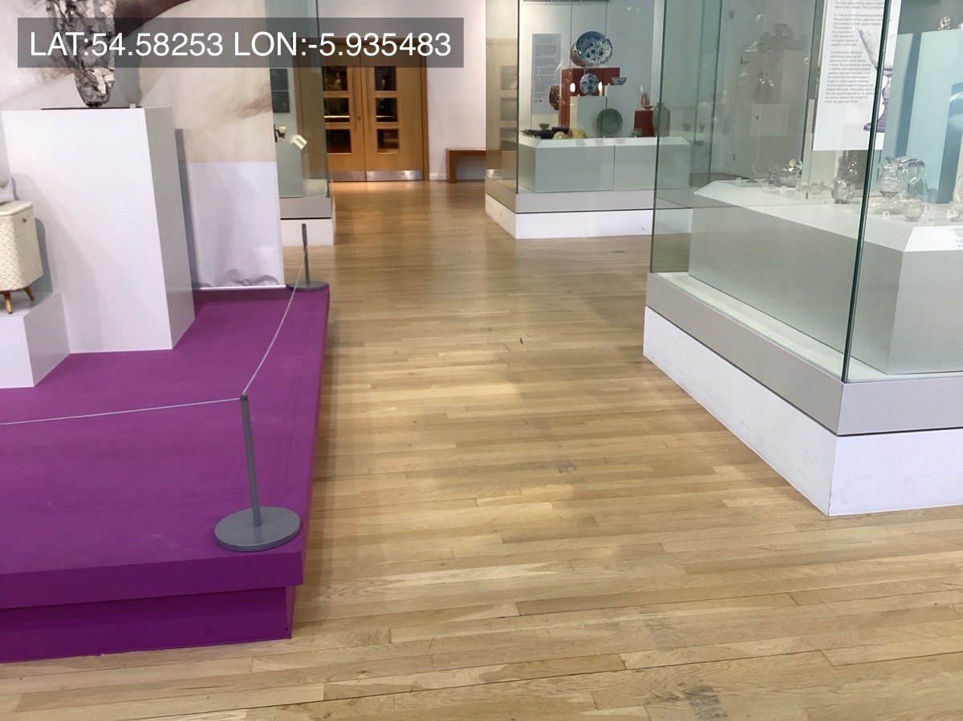
Exhibition spaces should include information in alternative formats and promote easy navigation of the space and story.
 |  |  | ü / û
10.1 | Seats with armrests and differing heights are provided at intervals along internal routes. Seating is colour contrasted with its background.
10.2 | Clear circulation routes around display cases are provided: width of 1800mm for major circulation routes and 1200mm for secondary circulation routes, with turning areas of 1800mm.
10.3 | Provide sufficient light on the circulation routes but avoid creating pools of light and shadow.
10.4 | Platforms for objects are not tripping hazards and do not project unpredictably into the path of travel. Platforms have colours that contrast with the floors and walls.
10.5 | Display cases have non-reflective glass.
10.6 | Interactives have a knee recess and/ or height adjustment to accommodate wheelchair users.  Controls are contrasted, making them easy to see, operable with a closed fist, and have tactile features.
10.7 | Audiovisual presentations display subtitles for people with hearing impairments, are transcribed or audio described.  British Sign Language translation is available.
10.8 | When there is a television show with no sound, or ambient audio is played, this is indicated accordingly.
10.9 | The overall layout of the exhibition space is reasonably clear and logical. Signage is available in Braille and Tactile formats.
10.10 | Maps are provided at entries to exhibitions and information desks, which enable planning of travel through complex exhibitions and outdoor areas. These should be available in alternative formats, e.g. tactile.

Actions: Exhibition space

11: Exhibition items
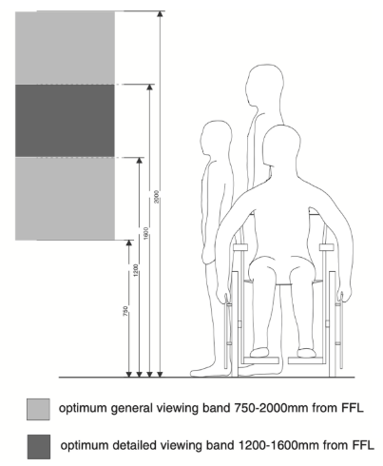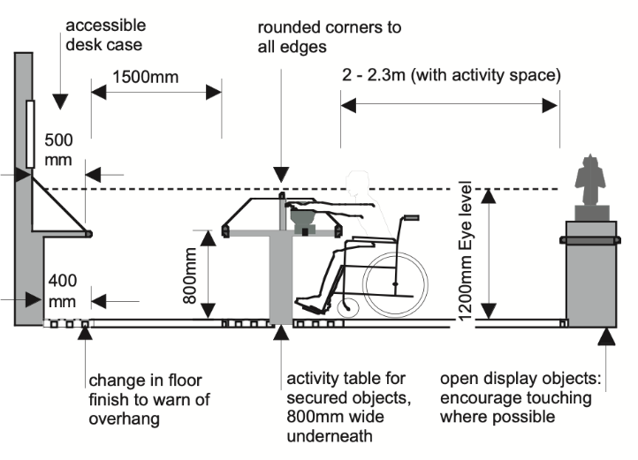
Source: Exhibitions for All
Accessible design ensures items on display can be enjoyed by all.
 |  |  | ü / û
11.1 | Wall mounted items are displayed at a comfortable viewing zone for both standing and seated individuals: between 750mm and 2000mm above floor level.
11.2 | Labelling of exhibits is in large, clear text and a sans serif font that many will find easy to distinguish. Labelling text contrasts with background colours, is printed on a solid background and not overprinted on images.
11.3 | Label sentences should be short, easy to understand and avoid jargon.
11.4 | Interactives are on accessible routes within reach of those seated and standing. All instructions are provided in both an audio and printed format.
11.5 | Place small items in the front portion of a case, with larger items behind. Provide photographs to give accessibility to objects that require a high mounting position and/or low lighting.
11.6 | Information on how you share your collection and how everyone can use and reference it is provided.
11.7 | Include items and objects of interest that can be touched and handled by all visitors, not just those who have low vision or are blind.
11.8 | Provide an audio description for objects that cannot be touched or that offer little information through touch (e.g. paintings).

Actions: Exhibition items

12: Site Management and Emergency Egress
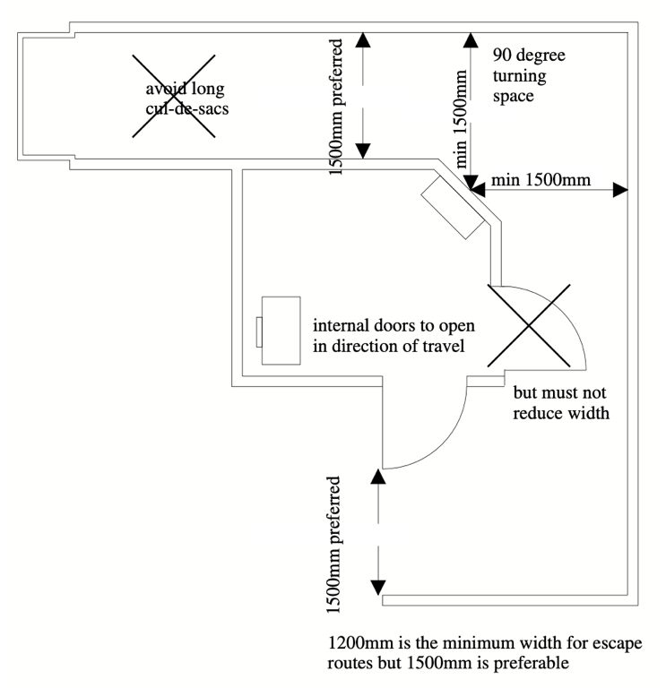
Source: Exhibitions for All
Communication, awareness training and proactive management ensure all visitors have a positive and safe experience.
 |  |  | ü / û
12.1 | The museum website is updated regularly with the latest accessibility information, including facilities and notification of any limitations due to breakdowns of lifts or any site maintenance.
12.2 | The museum website is accessible to all visitors.
12.3 | Staff receive regular disability and inclusion awareness training.
12.4 | Wayfinding signs are consistently placed and use symbols as well as words and visual clues.
12.5 | Fully accessible emergency egress from the exhibition space is possible. Provide refuges for rescue assistance if the number of accessible exits is insufficient, or on upper floors.
12.6 | Circulation and evacuation routes, including steps and ramps, are checked regularly for obstructions and are kept clean.
12.7 | Evacuation plans in place are regularly rehearsed and include assistance for disabled visitors/ staff.

Actions: Site Management and Emergency Egress

Action Plan
Select items, prioritising improvements relevant to your museum site and collections, to build your Action Plan.
Priority | Recommendations

